An integrated task on Sports (Student’s version)

Suggested levels: P2-P3

You learnt about sports in the English lessons and you want to find out more about the favourite sports of your family members and friends. Complete the following activities.

Part 1 Knowing different sports
- Look at the pictures below and write the names of the sports in the spaces provided.
Page 1
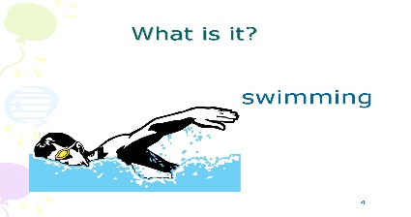 | 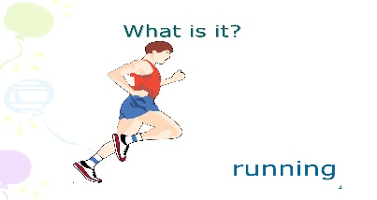
- ______________________ | - ______________________
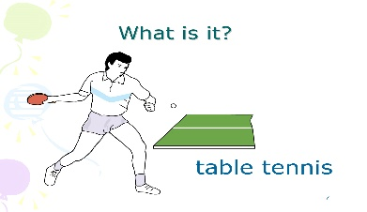 | 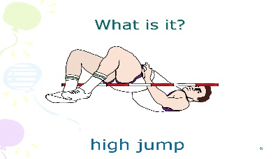
- ______________________ | - ______________________
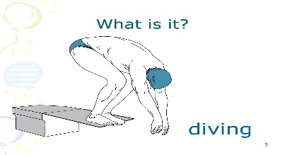 | 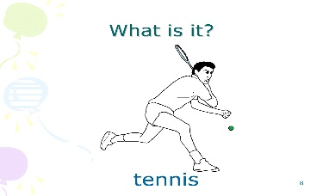
- ______________________ | - ______________________
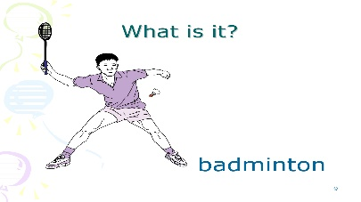 | 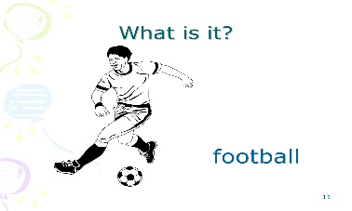
- ______________________ | - ______________________
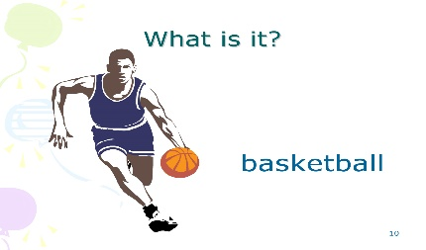 | 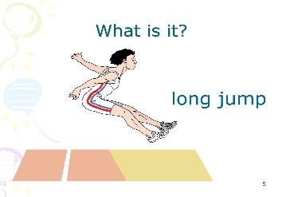
- ______________________ | - ______________________

- Can you divide the sports in Part 1A into different groups? Use a tree diagram to organise the different sports.

Your example: Your example: Your example:

- Do you know any other sports? Add one example to each group of sports.
You can search for more information about different sports on the following websites:
https://www.olympic.org/sports
https://tokyo2020.org/en/sports/
Page 2

- Read an article about the Olympic Games and answer the questions.

Olympic Games
The Olympic Games are held once every four years. There are different
kinds of games such as track and field events, ball games and water sports.

Running is a kind of track event. Runners need to run very fast on the track. It is very exciting when you see runners dash to the finish line.
Table tennis is a kind of ball game. Many children like playing table tennis because it is exciting. We need at least two players to play this game. Sometimes, there are four players when they team up.
Football is a thrilling ball game too. People feel excited and shout when they watch a football match. There are usually eleven players in each team.
Diving is a kind of water sport. Divers need to do different actions while jumping into the swimming pool. You cannot do this sport if you are afraid of water.

Page 3
Now answer the following questions.

- What are the three main kinds of sports in the Olympic Games?

________________________________________________________.

- Which sport needs two people to play together?

________________________________________________________.

- Which two games are in the same group? What is the group?

________________________________________________________.

- Which sport takes place in a swimming pool?

________________________________________________________.

- What does ‘thrilling’ mean?

________________________________________________________.

Page 4

Part 2 A survey on favourite sports
- Listen to the interviews on favourite sports. Fill in the answers and tick the correct boxes.

Teacher 1: Miss Leung
Favourite sport:

Reason(s): .. interesting exciting healthy

Where to play: beach . club house swimming pool

Teacher 2: Mr Jim
Favourite sport:

Reason(s): fun . exciting . healthy

Where to play: school playground park countryside

Teacher 3: Miss Cheung
Favourite sport:

Reason(s): . interesting exciting healthy

Where to play: school playground …. park . club house

Page 5

- Interview your family members and friends about their favourite sports. Ask the following questions and fill in the table below.
A: Good morning, . I’m doing a survey on favourite sports. May I ask you some questions?
B: Sure / Certainly.
A: What sport do you enjoy?
B: I enjoy .
A: I see. Why do you like this sport?
B: I like it because it is .
A: Okay. Where do you swim / play basketball / play football?
B: I swim / play basketball / play football .
A: I see. It’s the end of our interview. Thank you very much.
B: You’re welcome.
Favourite Sports of _________’s family members and friends
Who? | What? | Why? | Where?
e.g. Mary | e.g. playing football | e.g. healthy | e.g. in the school playground
____________
____________
____________
____________
____________
____________
Page 6

- Complete the bar chart on the favourite sports of your family members and friends with the data you got from the interview. Colour and label the bars.

Favourite Sports of ’s family members and friends

6
5
(no. of people)
4
3
2
1

________ ________ ________ ________ ________ ________

(names of sports)

Answer the following questions about the chart.

- What is the survey about? 1. __________________
- How many people did you interview? 2. __________________
- How many sports are there? 3. __________________
- Which is the most popular sport? 4. __________________

Page 7

Part 3 Write a summary about the survey. The following questions will help you.

- What survey did you do? What is it about?
- How many different sports were mentioned in your survey? What are they?
- Which is the most popular sport?
- What kind of sport is it (water sport / ball game / track and field event)?
- How many people like / enjoy it?
- Why do they like it?

A survey on

Page 8

